Student Campaigner Information Pack

Centrepoint is a registered charity number 292411.

What We Do
Centrepoint is the UK’s leading charity for homeless young people, supporting
almost 14,000 16-25 year olds into a home and a job every year.

As well as helping those in need now, we also work tirelessly to prevent others becoming homeless in future. That’s why we provide long term, specialist support for every young person in our services; providing each individual with a tailored pathway to independence.

Many young people go to extreme lengths to avoid the dangers of rough sleeping; resorting to sleeping on friend’s sofas, riding 24-hour transport, or even self- harming to stay in hospital or committing crime to stay in a police station; keeping the problem out of sight, and often, out of mind.

Centrepoint is the turning point. We are changing the story for homeless young people every day by offering safety and security; enabling, inspiring, and motivating young people to gain skills and jobs, helping them into living independently. Our aim is to end youth homelessness by 2037 and we need your help.

Role Overview
As a Student Campaigner you will act as an ambassador and help to raise awareness and fundraise for
Centrepoint at your university. You will bring your passion for ending youth homelessness to the role, where you will be able to influence others to support our crucial work across the UK.

By joining our team, you can be the start of lasting change in your community and beyond.

In return we’ll support you in developing CV enhancing skills and experience
to help you stand out from the crowd when it comes to applying for jobs!
Key Responsibilities
- Put on fundraising events at your university and encourage other students to sign up and get involved- this may be in your friend group or through a sports club/society!
- Liaise with Centrepoint representative and stay up to date with
Centrepoint fundraising events and news
- Speak to other students about Centrepoint and what we do
- Promote our campaigns and Centrepoint Helpline within your university and wider community
- Present our work within your club/society and put us forward to your RAG group
- Use and develop your skills to be a force for change in your local and wider community

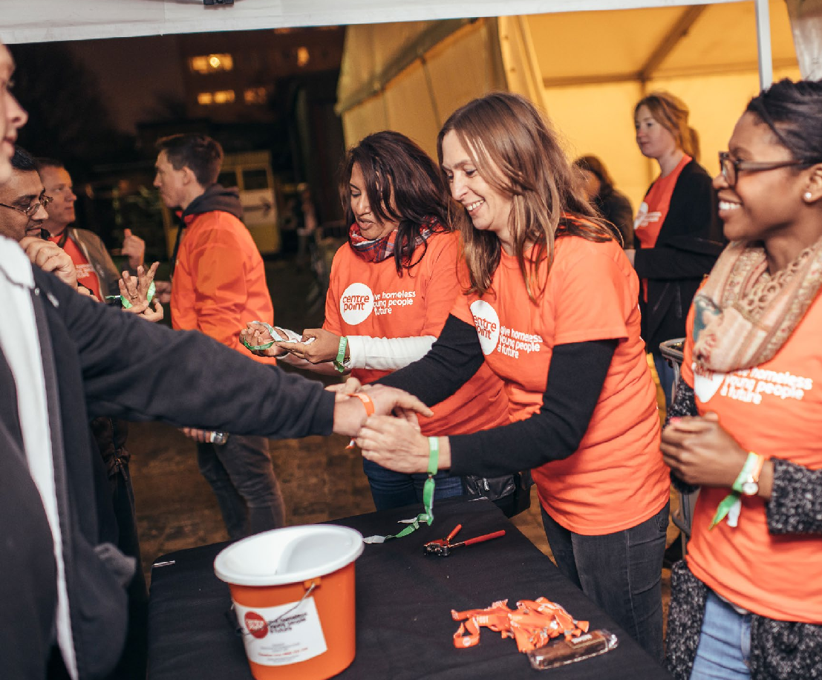

2 For more information, please contact us at events@centrepoint.org For more information, please contact us at events@centrepoint.org 3

Benefits of volunteering as a Student Campaigner
- Learning and developing skills which will benefit future applications to further education, volunteering roles or employment whilst also having fun
- You will gain experience of event planning, fundraising and of working in the third sector
- We can provide you with branded merchandise such as t-shirts, balloons, pens, and running/cycling t-shirts to improve the visibility of our partnership. We can provide you with physical and digital resources – information leaflets, videos, real stories, posters and graphics, digital content or copy for your online fundraising page to maximise their potential
- You will be supported by a Centrepoint representative who will be able to answer any questions and help you with your fundraising. They will also check in with you at regular intervals to ensure that you have everything you need!
- You will get a certificate and letter of achievement for your record of
achievement
- And, of course, you will be standing up for and supporting homeless young
people in your community

Top tips for planning your fundraiser

Set a target
Decide how much you want to raise. It’s great to have a realistic target to motivate those around you to help you reach your goal. Check out the “How your money helps” section to see the impact your fundraising
will have.

Decide on your event
Now you’ve set a target, it’s time to decide how to achieve it. What are your strengths and hobbies? Are you the motivator or the organiser of your group of friends? Think about your skills, those of the people around you and go from there. Remember to choose an activity you’ll enjoy, fundraising should be fun after all!

Speak to your Centrepoint representative
Now that you know what you hope to do, it’s time to get in touch your contact at Centrepoint. We’re here to help and answer any questions you might have. If you provide the ideas, we’ll provide the expertise and resources to help you make them a success.

4 For more information, please contact us at events@centrepoint.org For more information, please contact us at events@centrepoint.org 5

Bethany’s story: Determination moved me forwards
Bethany, 20, went into care at age 11 when her Grandmother passed away: ‘There wasn’t really anyone else suitable to look after me so I ended up in care that
way.’ She has been in four foster placements since then.

When she was 16, she fell pregnant and took her GCSE exams in her third trimester. Due to her pregnancy, she had to move into a new foster placement where she stayed until she was 18. She then was moved into supported housing before being
referred to Centrepoint in March of 2020.

‘Once at Centrepoint, I felt a lot freer and I was able to focus on myself and my son. Valda, my key worker, just gave me what I needed. She could see that I was independent and could do most things for myself. She helped me with things like service charges and understanding rent because it was all new to me. However, in terms of life skills – cooking and cleaning and things like that – she could see that I knew what I was doing. She basically understood where I needed help and where I didn’t and she listened to me. She just listened. She was like my mini therapist. It was helpful, rather than
an interrogation,’ she says.
Bethany moved into student accommodation when she started her degree at the London School of
Economics (LSE) where she is studying
International Social and Public Policy. She has an apartment, which accommodates both her and her son
and she continues to receive financial support from the Centrepoint bursary, which helps her to pay for childcare
whilst she is studying.

‘It is so important for me to be able to access full-time and long-term childcare. It was one of the things I worried about, but it’s actually going to be there for the duration which is amazing. It means that I can engage in a lot more activities that the university run. I want to be able to engage with as much of the university experience as possible.’
She says that eventually, she would like to start her own charity. We think
Bethany is is an absolute inspiration and wish her all the best for the future.

Your support means that we can be there to help give young people like Bethany a brighter future

6 For more information, please contact us at events@centrepoint.org For more information, please contact us at events@centrepoint.org 7

Fundraising ideas A-Z

Karaoke, Knitting sale,
Knockout pool
K

Music night, Marathon, Movie night
M

Orienteering, Obstacle course, Odd jobs day
O

Litter picking,
Lyrics quiz, Laughathon
L

Name the Bear,
N
Nominations

Pop up shop, Pantomime, Pyjama day
P

Auction, arts and crafts fair, afternoon tea
A

Coffee morning, Concert,
C
Comedy show

Enterprise competition,
E
Easter Egg hunt, Eco Day

Guess how many sweets, Games Day, Game show
G

Ice Skating, Ice cream social, individual challenges
I
Bake off, Bike
ride, Book swap
B

Dance show, Disco, Doughnut sale
D

Fashion show, Football match, Face painting
F

Head shave, Hair styling competition, Hip Hop dance off
H

Jumble sale, Jump rope competition, Joke competition
J
Question time,
Quiz
Q

Sleep Out/STAY UP
S

University Challenge, Unwanted items swap
U

World record attempt, Walking challenge, Wellie throwing
W

Yoga Class, Yoyo completion, Yodeling completion
Y
Raffle, Rugby
match, Race
R

Tombola, Treasure Hunt, Team Building
T

Varsity, Volleyball tournament, Vegan bake sale
V

X-Factor talent show, Xmas party
X

Zumbathon, Zip-wire challenge, Zorbing
Z

8 For more information, please contact us at events@centrepoint.org For more information, please contact us at events@centrepoint.org 9

Kickstart your fundraising
Set up your online fundraising page. Add a photo, make the story personal and share it with everyone you know.

Download a sponsorship form from
our website and collect donations in person. You can then pay the donations directly on to your own online page.

Be creative and think outside the box. It’s often the most imaginative and personal ideas that do the best.

Fundraising is much more fun if you work in a team. Recruit your friends to get involved too.

Share your story. Tell everyone why you’re raising money for Centrepoint and what it means to you.

As well as word of mouth, posters and social media, get in touch with your local press to them know what you are up to. We can also help you with a press release.

Have fun and enjoy the feeling of making a difference. You’re doing something incredible!

How your money helps
£12.50 could help us answer a young person’s call to our Helpline, investigate their issue and follow up with solutions to avoid homelessness

£15 could help provide a comfy bed and mattress and give someone their first decent night’s sleep in months

£40 could help pay for an initial mental and physical health assessment, so that a young person gets the support they urgently need

£65 could help pay for text books and course supplies, helping a young person study for college and build a new future for themselves

£100 could help provide a counsellor to support homeless young
people – this could be the first person they’ve trusted in a long time

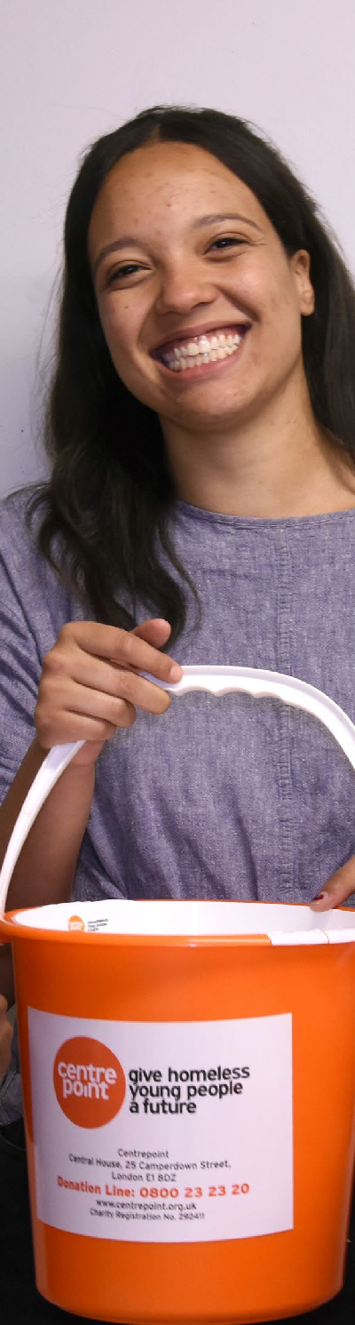
For more information, please contact us at events@centrepoint.org
11

10 For more information, please contact us at events@centrepoint.org

We can’t wait to hear from you!

Email: events@centrepoint.org Phone: 0800 587 5158
Address: Centrepoint, Central House, 25 Camperdown Street,
London, E1 8DZ

Centrepoint is a registered charity number 292411.

