Hope Star Winners 2021

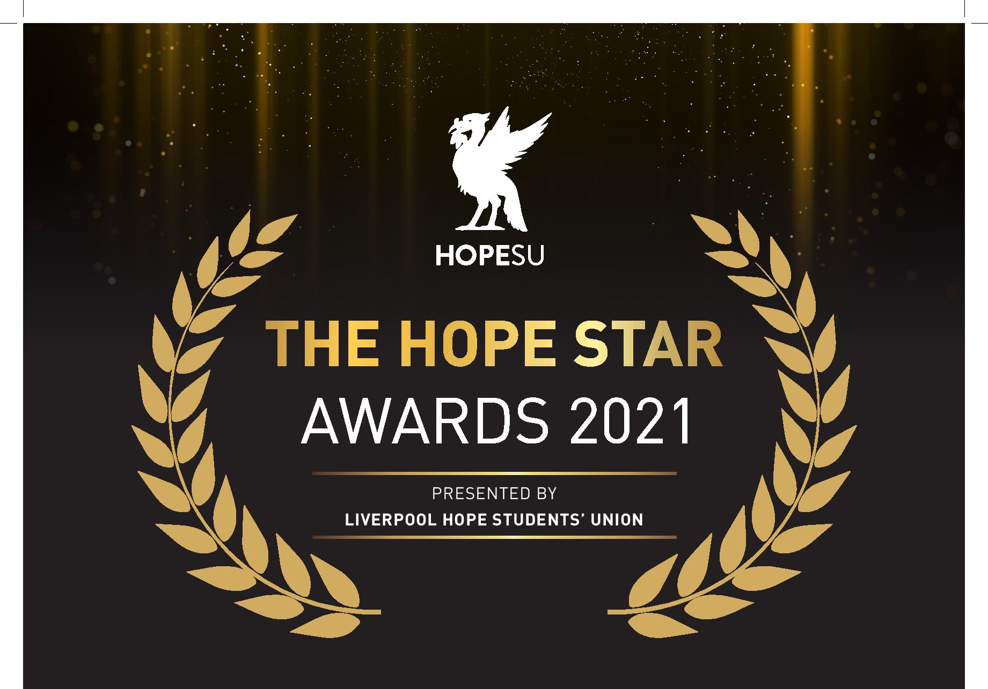

The List of winners is as follows
Student Awards

Outstanding contribution to EDI

Honourable Mentions

Louise Patterson Brown
Abigail Lavers
Winner Nicola Howard
Inspirational Student Award

Honourable Mentions

Poppy Euesden
Ifan Dafydd
Sarah Clarke
Winner Louise Lacey

Course Rep of the Year Award
Honourable Mentions

Daniel Shankland
Megan Rowley
Winner - John Raftery

Staff Awards
Innovation Award
Honourable Mentions

Mrs Joanne Lewis
Dr Sarah Hiett
Winner Dr Nicolas Garron
Student Opportunities Award
Honourable Mentions

Mr Richard Webb
Dr Harriet Pattison
Winner Mr Chris Biggs

Supportive Tutor Award
Honourable Mentions
Dr Ana Be Periera
Dr Marie Caslin
Winner Dr Laura Waite

Supportive Staff Award
Honourable Mentions

Mr Rob Cunningham
Mr Niall Doherty
Winner Mrs Anne Marie Isherwood

Thinkers Award

Honourable Mentions

Mrs Joanne Lewis
Dr Yvonne Ward
Winner Dr John Tilson

Inspiration Award
Honourable Mentions
Dr John Grant
Dr Babs Anderson
Winner Miss Tracey Ramsey
Hope Community Hero Award
Honourable Mentions

Dr Rose Devereux
Dr Laura Waite
Winner Miss Lily Nelson

Student Group Awards

Fundraisers of the year

Honourable Mentions
Islamic Society
Ewan Stannard
Joint winners
Cameron Sharpe and Kieran Goodwin

Contribution to Inclusivity

Honourable Mentions

Disability Studies Society
British Sign Language Society
Winner - International Relations Society
Society of the Year

Honourable Mentions

International Relations
British Sign Language
Winner Drama Society

Sports Team of the year

Honourable Mentions

Women’s Gaelic Football
Netball
Winner Men’s Rugby

President’s Award
Winner Inclusive Practice Working Group namely
- Mrs Caroline Pike
- Dr Marie Caslin
- Dr Ana Be Pereira
- Mrs Jacqueline Whittle
- Mrs Elpiniki Smith

