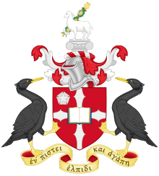

Hope Park Sports – Spectator Code of Conduct
Hope Park Sports is committed to safeguarding and promoting the well-being of all its staff, members and visitors.

Spectators/Parents and visitors to Hope Park Sports are asked to abide by the following Code of Conduct that aligns with similar HPS codes for Event organisers, supporting staff and participants -

- Abide by the policies of Hope Park Sports and the instructions/guidance issued by HPS Staff.

- In the first instance, contact the lead coach or event organiser with any issues or concerns.

- Report any maintenance related or other faults to HPS Staff if organiser coach unavailable

- Remain aware of emergency procedures and emergency exits

- To not use or tolerate inappropriate language.

- To not discriminate against anyone because of their age, gender, disability, culture, racial origin or religious belief.

- Respect the HPS facility and that you leave it in a clean and tidy fashion

- Be mindful and courteous to HPS staff and other teams and visitors outside of your session/booking

Visitors and Spectators are encouraged to be open at all times and to share any concerns or complaints that they may have about any aspect of the event with the Sport, Fitness and Development Manager

