Liverpool Hope Students’ Union

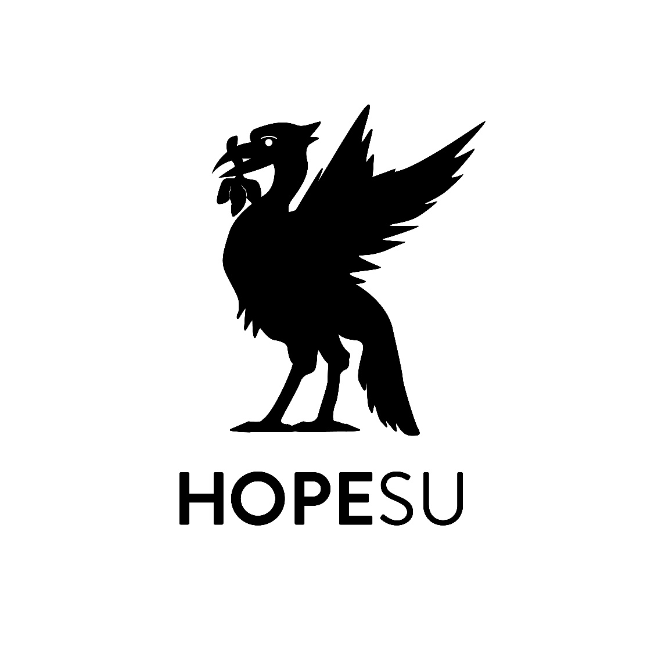
No Platform policy
August 2013
Version: 1.0

Approved by: | Students’ Union Executive
Date Approved: | August 2013
Lead Staff responsibility | Union Development Manager
Reviewed on: | November 2021

No Platform Policy

This Union Believes
1. Racism and fascism are still rife in many aspects of society and should be confronted wherever it is found.
2. In line with the Union’s safe space policy, the Union should be at the forefront of campaigns to combat prejudice.
3. The No Platform Policy compliments the safe policy of the Union and the Public Order Act.
4. That fascists actively campaign against the principles and practice of free speech and democracy.

This Union Further Believes
1. The No Platform Policy will safeguard our members from being subjected to the lies, bigotry and hatred of racists and fascists.
2. To safeguard and promote free speech and democracy we must not allow a platform to those who are against it.

This Union Resolves
1. Not to allow individuals known to hold racist or fascist views to attend or speak at Union events or of any affiliated Sports Team, Club or Society of the Union.
2. To campaign against any individual who is known to hold racist or fascist views being allowed to distribute any written or recorded material on campus or through University controlled websites which expresses racist or fascist views.
3. No elected officer of the Union will speak on or share a platform with any individual who is known to hold racist or fascist views.
4. No individual who is known to hold racist or fascist views shall be permitted to stand in any Union election or be a Union Trustee.
5. That the following groups and their members shall be defined as racists and/or fascists under this policy: The British National Party, The English Defence League, The True Brits.
6. That in the case of a dispute over whether a person does or does not constitute a racist or fascist, the Executive Council shall have final authority to define them so within the remit of this policy

*This document should be understood alongside the Union’s Safe Space Policy.

